**Design Report Template Milestone 6**

**Ryan Coon**

**CST-361**

**Professor Mark Smithers**

**July 10, 2022**

**CST-361 - Design Report Template**

|  |  |  |
| --- | --- | --- |
| **Topic:** | *Milestone 5* | |
| **Date:** | *July 3, 2022* | |
| **Revision:** | *5.0* | |
| **Team:** | 1. *Ryan Coon* | |
|  | |
|  | |
|  | |
| **Weekly Team Status Summary:** | |  |  |  |  | | --- | --- | --- | --- | | **User Story** | **Team**  **Member** | **Hours**  **Worked** | **Hours Remaining** | | *Update project management goals, objectives and tasks* | *Ryan* |  |  | | *Complete database service* | *Ryan* |  |  | | *Complete logging for console viewing* | *Ryan* |  |  | | *Update the UML diagrams for use cases, applicable classes, deployment and component* | *Ryan* |  |  | | *Update the wireframe designs* | *Ryan* |  |  | | *Update the ER database design* | *Ryan* |  |  | | *Complete a test plan* | *Ryan* |  |  | | *Update the design report from Milestone 5* | *Ryan* |  |  | |  |  |  |  | |  |  |  |  | |  |  |  |  | |  |  |  |  | |  |  |  |  | | |
| **GIT URL:** | *https://github.com/rcoon1/CST-361-CLC-Milestones/tree/main/Milestones* | |
| **Peer Review:** | *Y* | We acknowledge that our team has reviewed this report and we agree to the approach we are all taking. |

**Planning Documentation**

**Agile Scrum Product Backlog:**

*https://github.com/rcoon1/CST-361-CLC-Milestones/tree/main/Scrum-Sprint-Burndown*

**Agile Scrum Sprint Backlog:**

*https://github.com/rcoon1/CST-361-CLC-Milestones/tree/main/Scrum-Sprint-Burndown*

**Agile Scrum Burn Down Chart:**

*https://github.com/rcoon1/CST-361-CLC-Milestones/tree/main/Scrum-Sprint-Burndown*

**Agile Retrospective Results:**

*The following table should be completed after each Retrospective on Things That Went Well (Keep Doing). An alternative to the following table is to use a Mind Mapping tool such as Coggle. If you use a Mind Mapping tool you must include a URL or Image File.*

|  |
| --- |
| **What Went Well** |
| **Initial code design** |
|  |
|  |

*The following table should be completed after each Retrospective on Things That Didn’t Go Well (Stop Doing) and What Would Be Done Differently Next Time with an Action Plan to Improve (Try Doing and Continuous Improvement). An alternative to the following table is to use a Mind Mapping tool such as Coggle. If you use a Mind Mapping tool, you must include a URL or Image File.*

|  |  |  |
| --- | --- | --- |
| **What Did Not Go Well** | **Action Plan** | **Due Date** |
| **Took a little too much time with connecting the database. Kept getting errors.** | **Continue to get it completed by milestone 7** | **7/8/22** |
|  |  |  |
|  |  |  |

**Design Documentation**

**Install Instructions:**

Download war and import it into Eclipse. Open SQL Workbench and create a database named weathersaurus. Import SQL file and run on server.

**General Technical Approach:**

*While researching IoT, I came upon the decision of creating an application that captures and saves data for the weather. The IoT device will be emulated.*

**Key Technical Design Decisions:**

*Any final technical design decisions, such as framework decisions etc., should be documented here. This should list the technology/framework, its purpose in the design, and why it was chosen.*

**Known Issues:**

*Database connectivity working and basic website working. Having trouble with the table and chart.*

**Risks:**

No known risks at this time.

**ER Diagram:**

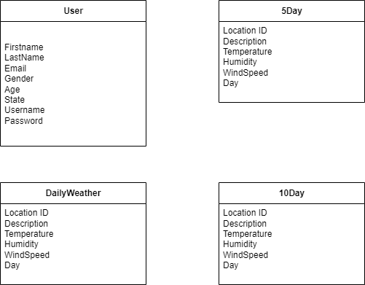

*Will need to set the 5 and 10 days to choose 5 and 10 days from the dailyweather column.*

**DDL Scripts:**

*https://github.com/rcoon1/CST-361-CLC-Milestones/blob/main/Milestones/Milestone%205/weathersaurus.sql.*

**Flow Charts:**

*You should insert any flowcharts here. Flowcharts should document algorithms or workflow that will be implemented in your program. At a minimum, this should contain a flowchart of the Minesweeper game logic.*

**Sitemap Diagram:**

*Image file of your Sitemap diagram.*

**User Interface Diagrams:**

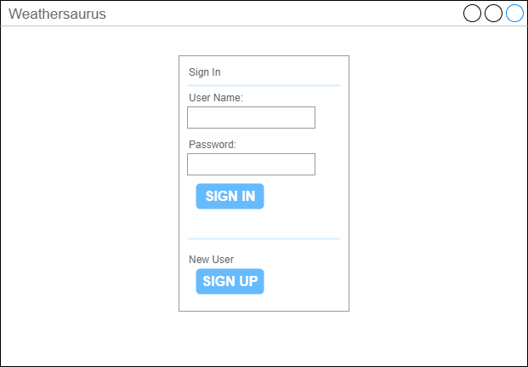

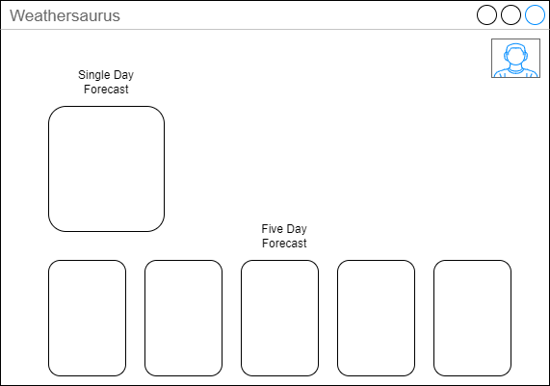

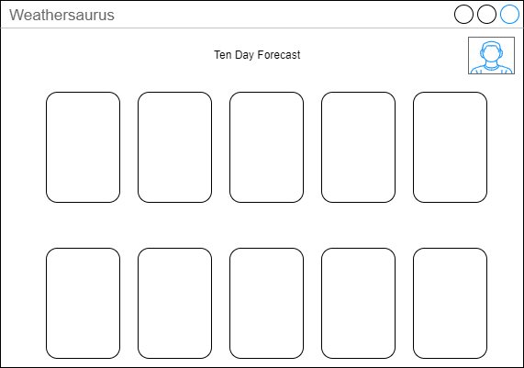

**Class Diagrams:**

**From Milestone 2:**

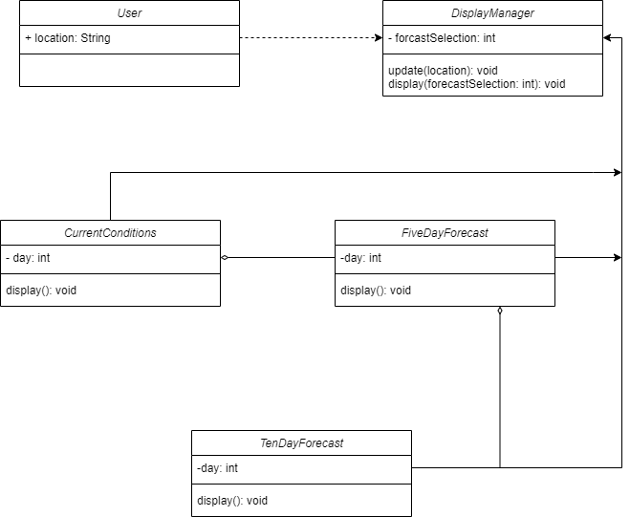

**Updated Class Diagram based on code written for milestone 3:**

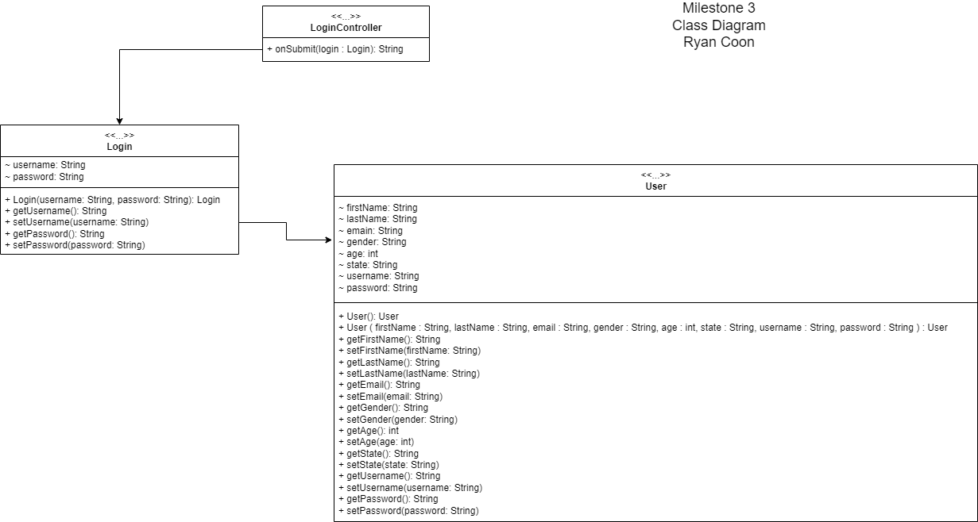

**Updated Class Diagram based on code written for Milestone 4:**

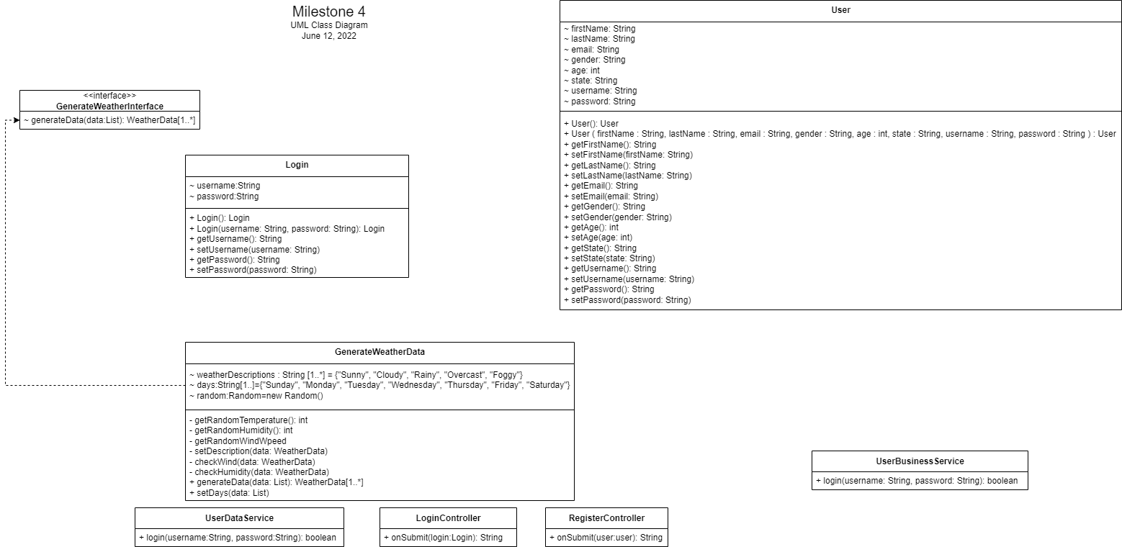

**Updated UML Class Diagram for Milestone 5:**

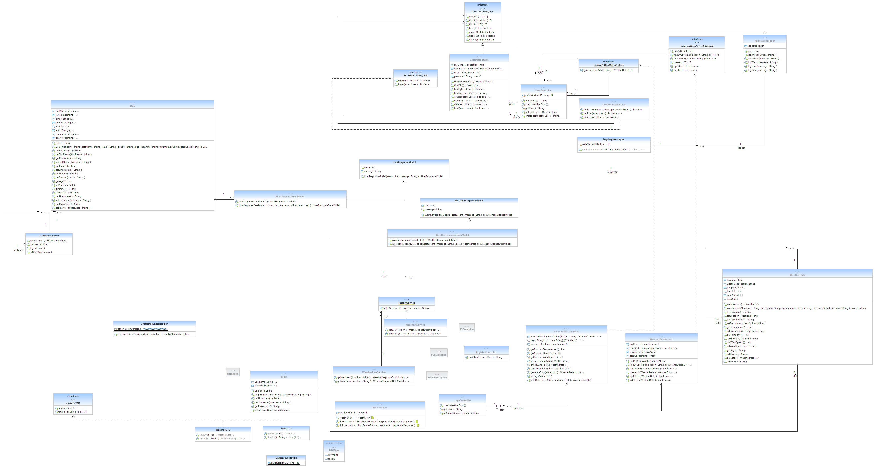

**Updated UML Class Diagram for Milestone 6:**

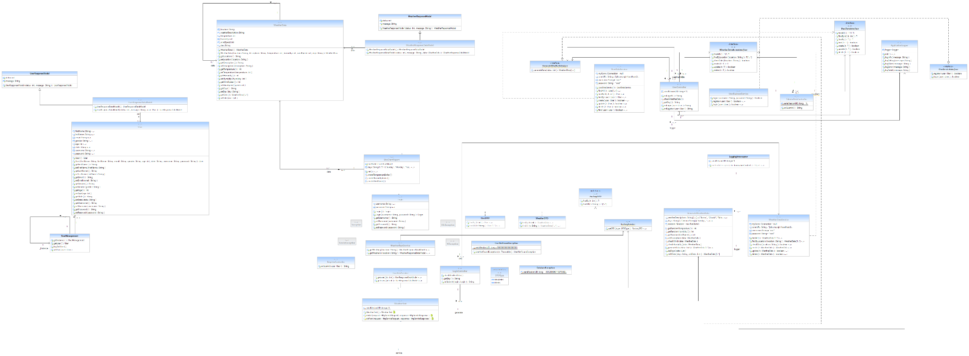

**Service API Design:**

*This section should fully document any Third Party Service Interface APIs being consumed or application specific Service APIs being published, how to access the service, what parameters are required by the API, and the detailed JSON data format specification that could be used by a third party developer to integrate with the service and API.*

**Security Design:**

*This section should outline the design for how authentication and authorization was supported. This section should also contain all of the roles and privileges that are supported by the design.*

**Pseudo Code:**

*https://github.com/rcoon1/CST-361-CLC-Milestones/tree/main/Milestones*

**Other Documentation:**

*Use Case Diagram:*

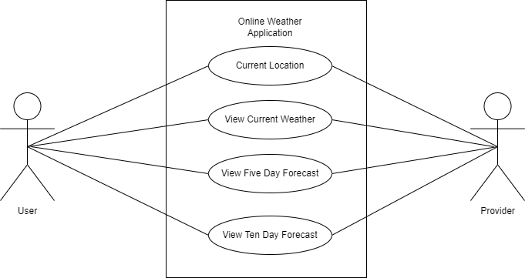

*Component Diagram: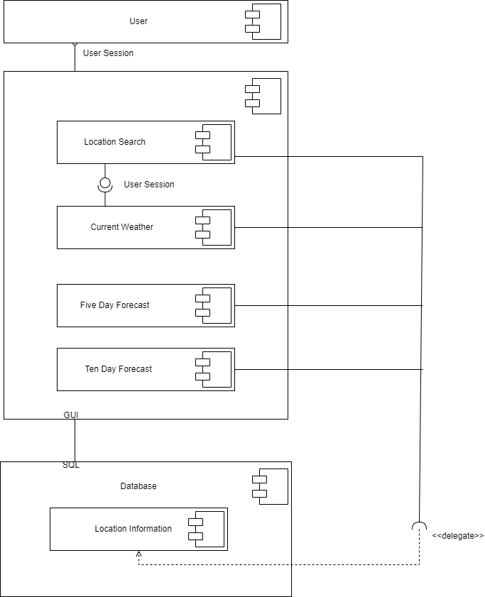*

*Deployment Diagram: